**HRM9039M Comparative Human Resource Management: Academic reflective essay**

**Table of Contents**

Introduction 3

HRM Practises Convergence and Divergence 3

Varying HRM Approaches 6

HRM Practises in the UK 8

Approaches to Recruitment and Selection, Performance Management and Talent Development 8

Conclusion 12

Reference List 13

# Introduction

The term "human resource management" describes a group of organizational duties that assist a company in managing its workforce efficiently at different phases of the employee life cycle. HRM is a managerial function that focuses on hiring, inspiring, and keeping employees in a company. It centres on the individuals within the company. Human resource management (HRM) is essentially a management function that handles an organization's hiring, hiring, training, and development of its human resources. It encompasses initiatives centred on maximizing an organization's utilization of its people resources. It concerns the cultivation of a very driven and efficient labour force.

In order to accomplish organizational objectives, it also entails organizing, obtaining, developing, employing, and sustaining "human resources." All people managers are accountable for human resource management, which is also a requirement of professional employment. It is the area of management that deals with employees and their interactions inside the organization. It encompasses all job areas and is not limited to business and industry. The specific skills and expertise involved in managing an organization's people resources are known as human resource management. It qualifies as a significant managerial task. This essay aims at discussing as well as evaluating the HRM practices of the UK. For this purpose, various aspects such as Convergence and Divergence model of HRM have been analysed in this task in a detailed manner.

# HRM Practises Convergence and Divergence

An organization's ability to effectively manage and develop its human resources depends on its human resource system. The dynamic and complex world of business presents numerous obstacles for HR professionals, necessitating innovative and inventive solutions. The strategic and operational facets of HR greatly benefit from the cognitive processes of divergent and convergent thinking (Bayraktaroglu et al., 2021). The future of work will increasingly depend on whether human resources within firms grow more similar (a divergence perspective) or more dissimilar (a convergence perspective).

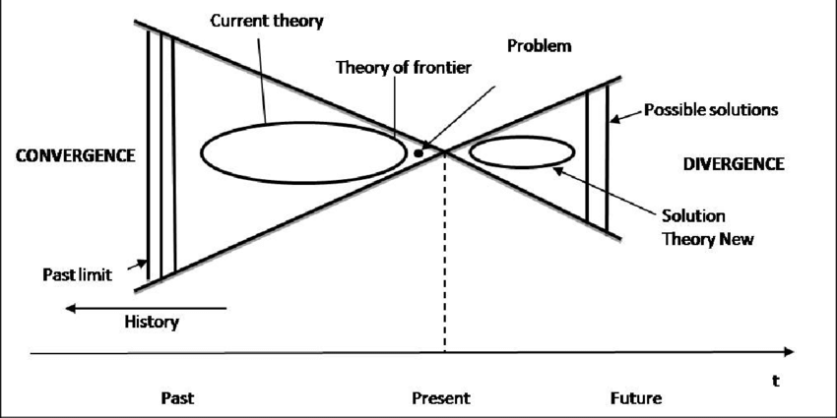

Figure 1: Convergence-Divergence Model

Source: (Saba, 2021)

***Convergence of HRM Practices***

By reducing the number of possibilities and selecting the optimal one, it encourages focused decision making. By weighing several choices and applying convergent thinking, HR may make decisions that are both efficient and successful. When determining the optimum course of action, this strategy takes organizational constraints, data, and resources into account. Convergent thinking also enhances one's capacity for critical analysis and problem-solving. HR professionals that thoroughly review information, take into account a variety of viewpoints, and apply logical thinking can make decisions that reduce risk and maximize favorable results. Divergent thinking ultimately guarantees congruence with the aims and objectives of the company (Bader et al., 2021). HR can make sure that its actions support the organization's overall performance and growth by contrasting suggested HR initiatives and strategies with the company's vision, mission, and core values.

***Divergence of HRM Practices***

The phrase “differences in human resource management practices” describes how international aspects of human resource management persist even in the face of widespread globalization in many industries. Because every country has unique cultural, legal, and institutional characteristics, human resource management strategies are designed to take into account local norms, values, and legal frameworks (Ausat et al., 2023). Dissonance exists in many firms when it comes to important HR procedures including hiring, performance reviews, and employee communications. There are clear distinctions between the UK and other nations with distinct histories, cultures, and legal frameworks. While globalization encourages the sharing of knowledge and management, the distinction acknowledges the significance of tailoring human resource management (HRM) strategies to each nation's unique needs as well as the various expectations and needs of the workforce diversity in various economic and socio-cultural contexts.

***Cultural Factors***

The practices of human resource management (HRM) in a nation or area are greatly impacted by cultural norms. Cultural elements including individuality and collectivism, power distance and uncertainty avoidance, and masculinity and femininity all have an impact on HRM strategies. These elements have an impact on goal-setting, leading teams, hiring practices, performance reviews, and employee interactions. Employee success will be rewarded in a culture that prioritizes individual achievement, for instance, whereas a more collaborative culture would stress the value of teamwork (Kamanzi and Irimoren, 2023). The development of human resource management strategies that resonate with employees, represent community values, and promote candid communication and collaboration necessitates an understanding of cultural diversity. Because of the multicultural nature of the UK, it is necessary to implement talent development and leadership techniques that consider the many cultural backgrounds of employees in order to maintain a calm and productive work environment.

***Legal and Institutional Context***

The majority of research on HRM and individual outcomes concentrates on the immediate effects; longterm effects are rarely studied. Moreover, a critical deficiency in the HRM literature is the "lack of good empirical research" that establishes a connection between employee views and corporate performance and various levels of analysis from HRM systems. But this type of research lacks context knowledge, much like SHRM does at the organizational level. This could account for some of the disparate results. In HRM, what functions well in one setting might not in another (Lyth et al., 2022). While it makes sense that other international not-for-profit organizations, such as governments, NGOs, and charities, might also fall under the category of international HRM, the focus of this field is on HRM in multinational corporations that operate internationally. A large percentage of the IHRM literature deals with problems pertaining to cross-border human mobility.

# Varying HRM Approaches

***Benefits***

**1. Focus on company goals*:*** When personal and professional goals are not in line, employees frequently feel dissatisfied and detached from their work, which can result in subpar output and, eventually, disengaged customers (Rubaca 2023). By incorporating goal-setting into their performance management procedures and connecting workers' individual and team objectives to the overarching organisational goals, human resource managers bridge the gap.

**2. Increased Employee Turnover*:*** Employees are a company's greatest asset, yet hiring new staff requires a lot of work. Hiring a new employee and training them as a replacement can cost twice as much as just turning over an existing employee (Stephenson et al., 2020). This is offensive to a positive work environment and not helpful. These terms and conditions will be precisely outlined in contracts that they will carefully draft.

**3.** **Better Conflict Management**: The systems for performance management are advantageous because they maintain staff motivation. Nonetheless, a person's pay and performance are frequently directly correlated in large organisations. Put another way, there will always be a possibility for someone to experience an increase in pay if they are continuously productive. However, if someone is unproductive, they might never feel that their worth is recognised at work.

***Implications***

**1. Recruitment of strong and emerging leaders:** There is a direct link between exceptional profitability and strong, effective leadership, which is crucial for both employee and company performance. There is still a case to be made for assisting current employees in realising their leadership potential, even though it is preferable to hire new leaders who already have all of these attributes. Last but not least, promoting from within gives younger staff members a clear indication of ambition, which will boost their performance and loyalty.

**2. Provision of value-adding trainings and seminars:** The UK enterprises must think about the benefits the training program will provide before selecting the one to provide. It will be simpler to persuade the person in charge of authorising the related charges that the money will be well spent if you can demonstrate a connection between increased profitability and good training (Hussain et al., 2020). There are, however, more nuanced dimensions of value to take into account. For instance, fostering a culture of respect among staff members through training that advances their professional or personal growth would raise employee engagement and help the company in the long run.

**3. Alignment with the business objectives:** The HR department as a whole needs to strive towards objectives that align with the business's overarching objectives in order to be genuinely effective (Halid et al., 2024). In order to optimise the impact and efficacy of a departmental effort, it is helpful to think about how the initiative might help the business achieve its objectives. Additionally, the HR team's dedication will be determined by their knowledge that their actions will aid the organisation in achieving its objectives.

***Challenges***

**1. Retaining top talent:** One of the primary causes of employee departures from an organisation is a decrease in employee engagement. Furthermore, people are always searching for better prospects for advancement and higher incomes due to the intense competition in the industry. They so frequently relocate to positions that provide greater prospects for advancement and financial gain. Providing brilliant individuals with sufficient bonuses or incentives to boost motivation and job satisfaction is the greatest approach to keep them on staff. The best methods for keeping talent include establishing flexible work schedules, providing monetary rewards, developing up skilling initiatives that are industry-specific, and more.

**2. Inclusion of Diversity and Inclusion in workplace:** HR should always endeavour to establish inclusive and diverse work environments because this promotes better work cultures and boosts organisational growth and efficiency (Malik et al., 2020). As easy as it may appear, fostering diversity and inclusion is not always easy. Language and communication difficulties, cultural misinterpretations, employee disagreements, and discrimination are the most frequent challenges that HR faces in the workplace.

**3. Promoting physical and mental well-being of employees:** The employees are more likely to work better and contribute to the expansion and success of the company when they feel valued, encouraged, and involved. However, when workers are overworked, depleted, or disengaged, their performance and productivity deteriorate, which lowers organisational performance. HR specialists should urge staff members to prioritise self-care and take breaks, as well as give them access to mental health resources like counselling services (Biron et al., 2021). Additionally, they ought to establish guidelines that support flexibility and work-life balance, such remote work options.

# HRM Practises in the UK

1. **Establish the required skill set**: Clearly define the required skill set for the HR role prior to beginning the talent acquisition process. Determine the precise knowledge, training, and experience needed to carry out this position. This guarantees that the companies of the UK draw in applicants who meet the requirements to meet the HR objectives of the company.

2. **Create a structured onboarding program**: UK companies’ human resource management encompasses a wide range of duties, such as conducting talent analyses for hiring purposes, offering a supportive work environment, implementing retention initiatives for top performers, and guaranteeing that every individual performs consistently. These several facets are crucial to HR (Sánchez-Monedero et al., 2020). Since employees cannot feel valued in the absence of HRM. Boosting employee self-esteem is a crucial skill that a proficient HR specialist should possess (Hecht, 2022). This is because those who believe they are more energetic than their colleagues are less likely to do those things. Furthermore, studies have demonstrated that a highly motivated employee increases a company's potential for success.

Furthermore, ensuring equality in a firm is a highly legal aspect when taking into account everyone's right to work in a safe atmosphere free from harassment and respect for human rights. People can work on their own schedule more freely when they use shift work. Therefore, a mother of a primary school student may work during the day while children are in school, while a student may have night-time job hours that do not conflict with their studies (Brandl and Braakmann, 2021). UK companies’ multicultural workforce is facilitated by flexible work schedules, which are crucial for communication and the advancement of religious equality (such as the rule requiring Orthodox Jews to abstain from Saturday labour). The employees tend to adjust to the mindset of each workplace community they are a part of. In fact, given that the UK has a diverse population, HRM is a crucial component in fostering a positive work environment (Hole et al., 2021). UK companies will also make sure that every worker is aware of their rights within the company and will look for ways to guarantee that the union backs the company's goals for the market.

# Approaches to Recruitment and Selection, Performance Management and Talent Development

***Recruitment and Selection***

There are distinctive number of steps involved in the selecting, opting along with filtering the right candidate for a particular job role or position within a company. Particularly, in UK, the businesses looking for recruiting new employees tends to perform an in-detailed analysis of job before selecting the most adequate candidate for the job role (Hussain et al., 2022). This forms the foundation of job descriptions as well as specification mentioned by the business for looking for the most eligible candidate in the recruitment process. Establishing inclusive and diverse workplaces is becoming a top priority for organizations in the United Kingdom. To do this, though, deliberate efforts are required to eliminate bias from the recruiting process and draw in applicants from a variety of backgrounds. Making contact with the references that candidates supply aids in confirming their credentials, background, and work ethic. By taking this step, you can be sure that the data in the application is accurate. There are many different ways that interviews can be conducted, including competency-based assessments, roundtable conversations, and one-on-one interviews.



Figure 3: Recruitment and Selection Process

(Source: Laczik and Emms, 2022)

Employers can assess a candidate's abilities, motivation, and cultural fit through these conversations (Chaudhari et al., 2020). After being hired, successful applicants go through an orientation process to become acquainted with the company's policies, procedures, and culture.

***Performance Management***

The UK's standardised performance evaluation system is influenced by individualism. Performance management supports the nation's emphasis on individual achievement by assisting workers in growing and progressing. The idea is to be consistent while recognising individuality. Performance metrics are applied fairly, with clear and open communication as well as enough training (Rajbhandari et al., 2021).

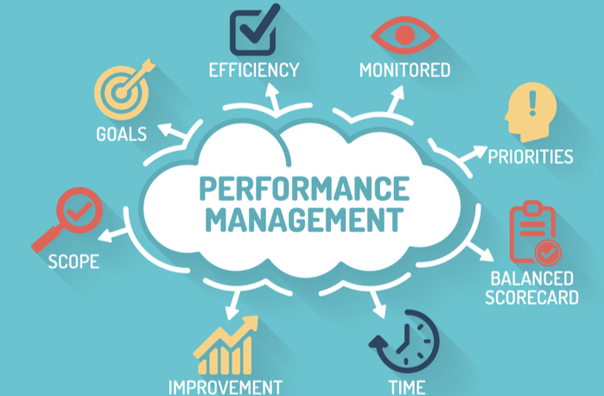

Figure 4: Performance Management

(Source: Brandl and Braakmann, 2021)

Employee engagement and advancement are driven by performance conversation and feedback. The organisations in the UK are streamlining performance management with technology, following the global trend. Aligning organisational and personal goals is challenging. Performance evaluations need to incorporate both quantitative and qualitative findings in order to comply with international norms and the UK's focus on personal evaluation. The UK's performance management system serves as an example of how difficult it may be to balance personal growth with global objectives in a cutthroat setting.

***Talent Development***

The UK's talent development programmes advance both nationally and globally. The UK's emphasis on post-secondary education and vocational training has an impact on these methods. A highly trained workforce exists in the UK thanks to programmes for ongoing education and training. The "Apprenticeship Levy" in the UK promotes the development and utilisation of local talent (Laczik and Emms, 2022). With the help of this targeted approach, support UK demand and worldwide skills development. It is challenging to update these plans due to the ever-evolving demands of the market and global business trends. The varied workforce in the UK and the quickly evolving workplace necessitate creative methods to training and education. The UK's emphasis on skills development and the rise of technology-based learning are two examples of how adaptable talent development programmes are. In order to provide its workforce with the skills necessary to adapt to shifting circumstances and global competitiveness, the UK needs to adopt a talent development strategy that considers the needs of other nations and regions in addition to its own.

***Employee Relations***

Due to historical, cultural and legal factors, industrial relations in the UK are both comparable to and different from those in other parts of the world. The core principles of earlier British labour and trade union movements were collective bargaining, worker engagement, and workers' rights (De Stefano and Taes, 2023). This defies international trends and shows how committed the nation is to workplace justice and worker development. Globalisation has resulted in a convergence. In order to improve an organization's flexibility and efficiency, remote and flexible working is quickly becoming the standard worldwide.



Figure 5: Employee Relations within businesses

(Source: Malik et al., 2020)

The employment law in the UK and European regulations were harmonised prior to Brexit. Negotiation and administration of workers' rights, both collective and individual, need to be done with professionalism. Global efficiency demands and the historical legacy of labour are causing a shift in the characteristics of the workplace in the UK (Mamonova and Franquesa, 2020). The employees need to be respectful of one another's cultural customs if they are to collaborate harmoniously and successfully.

# Conclusion

It has been inferred that a culture that places a higher priority on individual achievement will praise employee success, whereas a more collaborative culture will highlight the need of teamwork. This topic focuses on HRM in multinational firms functioning globally, while it makes sense that other international non-profit organisations, such governments, NGOs, and charities, may also fall under this category. While it is preferable to select new leaders who already possess all of these attributes, there is still a need to assist current employees in realising their leadership potential. HR specialists should give employees access to mental health resources like counselling services and encourage them to prioritise relaxation and self-care. In the UK, a competitive advantage is crucial for attracting and retaining HR professionals. The executives must ensure that businesses are competitive by comparing pay and perks to those in the same field. Utilising this focused strategy, support the expanding demand for UK capabilities globally. The dynamic nature of global business trends and shifting market demands makes it challenging to maintain these goals.

# Reference List

Ausat, A.M.A., Al Bana, T. and Gadzali, S.S., 2023. Basic capital of creative economy: The role of intellectual, social, cultural, and institutional capital. *Apollo: Journal of Tourism and Business*, *1*(2), pp.42-54.

Bader, A.K., Bader, B., Froese, F.J. and Sekiguchi, T., 2021. One way or another? An international comparison of expatriate performance management in multinational companies. *Human Resource Management*, *60*(5), pp.737-752.

Bayraktaroglu, S., Atay, E. and Ilhan, H., 2021. A passenger running west on a ship headed east: positioning Turkish HRM on the convergence and divergence continuum. *Management Research Review*, *44*(1), pp.25-58.

Biron, M., De Cieri, H., Fulmer, I., Lin, C.H.V., Mayrhofer, W., Nyfoudi, M., Sanders, K., Shipton, H. and Sun, J.M.J., 2021. Structuring for innovative responses to human resource challenges: A skunk works approach. *Human Resource Management Review*, *31*(2), p.100768.

Brandl, B. and Braakmann, N., 2021. The effects of collective bargaining systems on the productivity function of firms: An analysis of bargaining structures and processes and the implications for policy making. *Industrial Relations Journal*, *52*(3), pp.218-236.

Chaudhari, B.S., Zennaro, M. and Borkar, S., 2020. LPWAN technologies: Emerging application characteristics, requirements, and design considerations. *Future Internet*, *12*(3), p.46.

De Stefano, V. and Taes, S., 2023. Algorithmic management and collective bargaining. *Transfer: European Review of Labour and Research*, *29*(1), pp.21-36.

Halid, H., Ravesangar, K., Mahadzir, S.L. and Halim, S.N.A., 2024. Artificial Intelligence (AI) in Human Resource Management (HRM). In *Building the Future with Human Resource Management* (pp. 37-70). Cham: Springer International Publishing.

Hecht, K., 2022. ‘It’s the value that we bring’: performance pay and top income earners’ perceptions of inequality. *Socio-Economic Review*, *20*(4), pp.1741-1766.

Hole, G., Hole, A.S. and McFalone-Shaw, I., 2021. Digitalization in pharmaceutical industry: What to focus on under the digital implementation process?. *International Journal of Pharmaceutics: X*, *3*, p.100095.

Hussain, B., Sheikh, A., Timmons, S., Stickley, T. and Repper, J., 2020. Workforce diversity, diversity training and ethnic minorities: The case of the UK National Health Service. *International Journal of Cross Cultural Management*, *20*(2), pp.201-221.

Hussain, Z., Rizvi, L.J. and Sheikh, H., 2022. The Equality Act (2010)-pre-and post-pandemic historic development on equality and discrimination issues for employers: review of literature. *International Journal of Law and Management*, *64*(2), pp.168-183.

Kamanzi, A. and Irimoren, G., 2023. Beyond Borders: Heads of Departments navigating cross-cultural differences within their teams.

Kelly-Lyth, A., Abraha, H. and Adams-Prassl, J., 2022. From ‘Code’to ‘Guidance’: Revising the Instrument on Data and Employment. *Industrial Law Journal*, *51*(3), pp.744-761.

Laczik, A. and Emms, K., 2022. Apprenticeship resilience: UK-England. *The European Centre for the Development of Vocational Training (Cedefop)*, p.72.

Malik, A., Pereira, V., Budhwar, P., Froese, F.J., Minbaeva, D., Sun, J., Nguyen, A.T. and Xue, S., 2022. Multilevel relational influences on HRM practices: a cross-country comparative reflective review of HRM practices in Asia. *Asian Business & Management*, *21*(5), pp.745-779.

Mamonova, N. and Franquesa, J., 2020. Populism, neoliberalism and agrarian movements in Europe. Understanding rural support for right‐wing politics and looking for progressive solutions. *Sociologia Ruralis*, *60*(4), pp.710-731.

Rajbhandari, S., Ruwase, O., Rasley, J., Smith, S. and He, Y., 2021, November. Zero-infinity: Breaking the gpu memory wall for extreme scale deep learning. In *Proceedings of the international conference for high performance computing, networking, storage and analysis* (pp. 1-14).

Rubaca, U., 2023. Readiness to manage more diversity and inclusion to gain competitive advantage in changing landscape of the workplace.

Saba, C.S., 2021. Convergence or divergence patterns in global defence spending: further evidence from a nonlinear single factor model. *Peace economics, peace science and public policy*, *27*(1), pp.51-90.

Sánchez-Monedero, J., Dencik, L. and Edwards, L., 2020, January. What does it mean to'solve'the problem of discrimination in hiring? Social, technical and legal perspectives from the UK on automated hiring systems. In *Proceedings of the 2020 conference on fairness, accountability, and transparency* (pp. 458-468).

Stephenson, J.H., Persadie, N., Bissessar, A.M., Esnard, T., Stephenson, J.H., Persadie, N., Bissessar, A.M. and Esnard, T., 2020. Equality Laws Compared: The Caribbean, the UK and the USA. *Diversity, Equality, and Inclusion in Caribbean Organisations and Society: An Exploration of Work, Employment, Education, and the Law*, pp.157-183.